aim games  
Sprint 3 retrospective

# Summons

|  |  |
| --- | --- |
| Name | Roll |
| De la Fuente Bonilla, Fco. Javier | **CEO, Project manager** |
| Molina Domínguez, Jorge Manuel | **CCO, CIO** |
| Bizcocho González, Mario | **CMO, Product Owner** |
| Arenas Arenas, Antonio  Monteseirín Puig, Alejandro  Pazo Jiménez, Pablo  Pérez Piñero, Iván  Santos Batista, Miguel | **Developers** |

# attendee

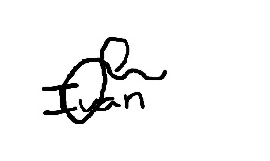**De la Fuente Bonilla, Fco. Javier Pérez Piñero, Iván**

**Arenas Arenas, Antonio Molina Domínguez, Jorge Manuel**



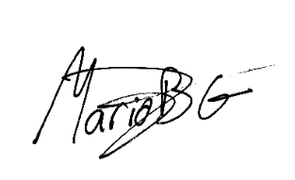**Monteseirín Puig, Alejandro Bizcocho González, Mario**

**Santos Batista, Miguel Pazo Jiménez, Pablo**

# Absent

No Proceed

# Date and place

Being on Friday 03 May 2019, and verified the attendance of all the summoned, began at 10:00 hrs. To the Sprint 1 retrospective and Sprint 2 planning for the AIM GAMES project, which ended at 13:30 hrs.

# AGENDA

1º Review of things created to date and lessons learned

2º Planning of the next iteration

# Development of the meeting and agreements

## Review of things created to date and lessons learned

We have had a little chaotic start of the spring because we everyone had obligations with exams of other subjects so the development of the project was secondary, and the team communication was low, but we could solve this near the end of the first week.

Solved this we had a smoot sprint, and with only a little problem with payment with PayPal, finished in time.

We think that we are prepared to tackle the last part of this project, finish the business plan and prepare the launch day.

## Planning of the next iteration

We will wait until the Monday 13, May for the exact plan, but it will be related with the preparation of the launch day and finish the business plan

# Signed in conformity

